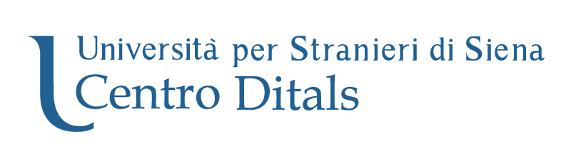
DITALS
Certificazione in Didattica dell'Italiano come Lingua Straniera
(Certificate in the Teaching of Italian as a Foreign Language)
1st-LEVEL DITALS, OPERA SINGERS profile

Since 2005, the DITALS Research and Administration Centre has been carrying out research on the planning, outlining and administration of the DITALS Certificate (Certificate in the Teaching of Italian as a Foreign Language).
At the same time, the Centre holds promotional and training activities in the field of L2 Italian Teaching, in addition to providing services for students, teachers and personnel operating within the same domain.
The DITALS Certificate attests three competence levels in the teaching of Italian as a foreign language, in line with the EPG - European Profiling Grid project’s guidelines - http://www.epg-project.eu/
The DITALS BASE certificate is mainly suitable for teachers who are not native speakers of Italian – and generally for anyone who plans to become a teacher of L2 Italian. It attests beginner’s level competence in the teaching of Italian as a foreign language.
1st-LEVEL DITALS attests specific competence in the teaching of Italian as a foreign language to a specific target learner profile, along with basic competence in language teaching theory.
2nd-level DITALS certifies advanced competence in the teaching of Italian as a foreign language and is suitable for teachers operating in any teaching context with any group of learners. Some of the necessary requirements for applying for 2nd-level DITALS can be replaced by possession of 1st-level DITALS.

1st-LEVEL DITALS attests good competence in the teaching of Italian as a foreign language with special reference to a specific target learner profile chosen by the candidate: children, adolescents, adult and elderly learners, immigrants, university students, Italian heritage learners, learners sharing the same L1 (Chinese, Arabic, Japanese, Russian, German), people working in the tourism industry, clerics, University Study Abroad students and opera singers (the last profile will be introduced starting from 2018 1st-LEVEL DITALS exam sessions). The range of 1st-LEVEL DITALS profiles results from thorough consideration of possible teaching contexts, learners’ age and learners’ motivation, taking into account the changing landscape of contemporary society.

1st-LEVEL DITALS for OPERA SINGERS
In teaching contexts where languages are learned for professional reasons, acquiring specialized competence is of crucial importance. Such competence must include the necessary knowledge to plan and implement qualified teaching intervention tailored to different and concrete teaching environments. In this perspective, the new opera singers learner profile emerges as a relevant one, to be included among 1st-LEVEL DITALS profiles in 2018. The profile specifically addresses teachers of Italian as a foreign language in public or private music conservatories in Italy and abroad. The profile specificity lies in the provision of the most suitable teaching methodologies for learners to develop the essential linguistic and pragmatic competences to sing entire operas or single arias in Italian (pronunciation, text comprehension, scene interpretation), to be able to read opera librettos written in literary Italian between the XVII century and the early XX century, and to interact orally with classmates, teachers and in the professional music-related contexts where Italian is used as the language of communication.

1st-LEVEL DITALS, OPERA SINGERS profile

Target applicants:
Italian and foreign citizens holding a high-school diploma and having experience in the teaching of Italian as a foreign language or in classroom training with learners of Italian as a foreign language.

Necessary requirements:
- Italian and foreign citizens (C1-level according to CEFR standards if mother tongue is not Italian)
- High-school diploma or university degree
- At least 60-hour experience in the teaching of Italian as a foreign language* or classroom training with learners of Italian as a foreign language
- At least 24-hour language teaching training
- At least A2 proficiency level in a foreign language**
- Technological and multimodal competence**
* this also includes the teaching of other subjects, where at least 15 hours are devoted to the teaching of L2 Italian
** possession of these requirements will be verified during the examination (candidates holding language or IT certifications are exempted)

Structure of 1st-LEVEL DITALS examination:
- SECTION A: Guided analysis of teaching materials (based on learner profile)
- SECTION B: Guided analysis and teaching application of an input text (based on learner profile)
- SECTION C: General and specific language teaching competences applied to the target profile
Total examination time: 4 hours
Course validity and exam sessions
- Examinations: participants will be able to retake any failed examination sections within 3 years from the first examination date
- Orientation course: unlimited validity in time
- Exam calendar:
1st-LEVEL DITALS exam sessions are held twice a year in dates set by the DITALS Certification Centre (Centro di Certificazione DITALS):
- 20th April 2018
- 16th November 2018

Partner institutions for exam administration
DITALS examinations can be taken in Siena or in a Centre partner institution in Italy and abroad.
Information
Information on DITALS examinations is available on the University for Foreigners of Siena website, DITALS Centre section: http://ditals.unistrasi.it/

Further information is available at ditals@unistrasi.it

